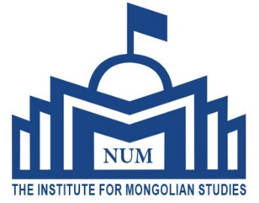

TWO WEEKS IN-COUNTRY SUMMER COURSE ON MONGOLIAN LANGUAGE AND CULTURE
WHERE: The Institute for Mongolian Studies, the National University of Mongolia
WHEN: 3rd August-16th August, 2025
TUITION FEE: USD 1500.00
TUITION FEE covers costs related to 1) course teaching and study materials, 2) accommodation and three meals (breakfast, lunch and dinner) 3) museum and natural park tickets, 4) local transports which include country-side tour, airport transport (pick up and airport transfers).
International travel costs, Mongolian visa fee and personal expenses are NOT included in the tuition fee.
ACCOMMODATION: The participants will be accommodated at the International Student Hostel of the National University of Mongolia in Ulaanbaatar and in Mongolian traditional ger in countryside.
Those participants arrive earlier or depart later due to flight schedule can stay at the International Student Hostel at the cost of 10 US dollars per day. In any case, the Institute for Mongolian Studies will arrange two-way transportation from the Chinggis Khan international airport.
VISA: When required, participants should obtain Mongolian visa. The visa should be valid for the period of the summer school. Please make an enquiry from Mongolian Embassy in your home country in respect to Mongolian visa requirement. The Institute for Mongolian Studies will assist you with the visa issues if deemed necessary.
INSURANCE: Health and travel insurance must be covered by the participants in their home country.
PROGRAMME: The Institute for Mongolian Studies will offer an intensive course on Mongolian language and Mongolian culture and society. In addition to class teaching, the Institute for Mongolian Studies will organise historical and cultural tour in Ulaanbaatar as well as in countryside to experience Mongolian nomadic culture and nature.
Those interested to participate in the summer course, please submit the Enrolment Form no later than 1st of July, 2025 to the Institute for Mongolian Studies.
PAYMENT: All fees are payable in US dollars with bank transfer charges if there it is required.
A participant may pay an initial payment of 200 US dollars or the total amount of fee.

BANK DETAILS FOR THE PAYMENT:
GOLOMT BANK OF MONGOLIA
Branch No. 1, Ulaanbaatar, Mongolia,
Bank account holder: The Institute for Mongolian Studies USD Bank Account : 1165102327
Bank account holder name: MUIS-MSKHUREELEN SWIFT CODE: GLMT MNUB

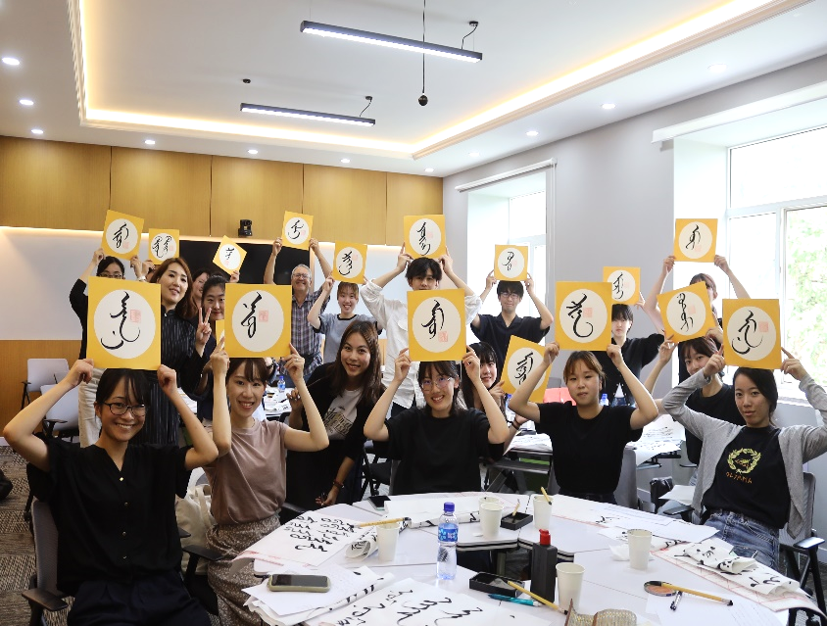
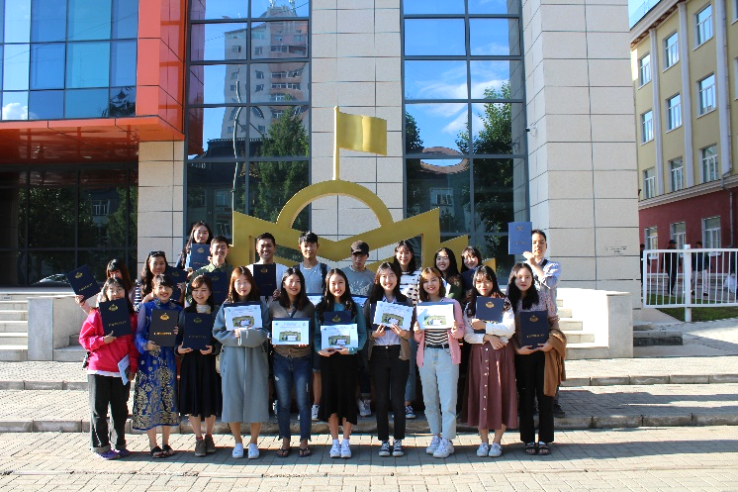

COURSE PROGRAMME

Day 1 - The open ceremony. Tour at National University of Mongolia & Visit to Chinggis Khan Square
Day 2 - Mongolian language class. Visit to Mongolian National History Museum, Ulaanbaatar.
Day 3 - Mongolian language class. Visit to Bogd Khan museum & Zaisan Hill Memorial
Day 4 - Mongolian language class. Visit to Chinggis Khan museum
Day 5 - Drive to Terelj National Park & Turtle Rock Formation and stay over at camp (horse riding).
Day 6 – Mongolian culture activities and stay over at camp.
Day 7- Visit to Tsonjinboldog (Equestrian statue of Chinggis Khan) and drive back to Ulaanbaatar.
Day 8 - Mongolian language class. Visit to Zanabazar Fine Arts Museum
Day 9 - Mongolian language class. Cultural Performance by Mongolian National Song and Dance Tumen Ekh Ensemble
Day 10- Mongolian language class. Visit to Choijin Lama temple
Day 11- Drive to Aglag Buteel monastery
Day 12- Mongolian language class. Watch Mongolian movie (Shangri-La mall Urgoo cinema)
Day 13- Mongolian language class. Visit to Department store & Narantuul market
Day 14 -Certificate giving ceremony. Farewell party dinner.
Detailed course programme will be provided upon arrival.

PLEASE CONTACT FOR MORE INFORMATION AND ENQUIRY:
Email: infomonstudies@gmail.com
Tel: +976-77307730 (ext 1192 or 1178)
Cell phone: +976-99498957
The Institute for Mongolian Studies The National University of Mongolia
Room No.323, University Building No.2, Sukhbaatar District, Ulaanbaatar, Mongolia http://ims.num.edu.mn/
https://www.facebook.com/IMS.NUM1991

PHOTO |  | 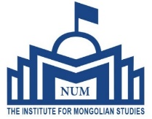  ENROLLMENT FORM FOR SUMMER SCHOOL INSTITUTE FOR MONGOLIAN STUDIES NATIONAL UNIVERSITY OF MONGOLIA  2025
1. Surname
2. Given name
3. Date of birth (dd-mm-yyyy) | 4. Sex  - Male  - Female |  |  | 5. Nationality |  | 6. Place of birth
7. Passport number | - Types of Passport  - Ordinary  - Diplomatic  - Official |  |  | 9. Date of issue |  | 10. Place of issue |  |  |  | 11. Issuing authority |  |  | 12.Expiry date
13. Marital status  □ Single □ Married |  |  | 14. Spouse’s nationality |  |  | 15. Spouse’s name
16. Occupation or what grade do you study in? |  |  | 17. Name and Address of University/Organisation
18. Telephone number(s) |  |  | 19. Main purpose of the journey (for visa use)
20. Intended date of arrival |  |  | 21. Duration of the intended stay
22. Home Address

Telephone number(s)
23. Address in Mongolia (if you are resident)  Telephone number(s) |  |  |  |  |  |  |  |  | 24. Previous visit to Mongolia (if any)  □ Yes □ No
25. Have you ever been issued a Mongolian visa?  When Where |  |  |  |  |  | □ Yes | □ No  Type of visa
26. Do you need Mongolian visa or not?
27.Accompanying family (if) |  |  | Nationality |  | Name |  |  |  |  |  | Sex | Date of birth
29. Reference in Mongolia (if applicable) |  |  | Name |  | Telephone number(s) |  |  | Address |  |  |  | Relationship

Date of application: Signature of the applicant:
FOR OFFICIAL USE ONLY
August 3-16, 2025 | Payment | USD
 | Full
 | Deposit

For further information, please contact us: e-mail: infomonstudies@gmail.com Website: http://ims.num.edu.mn/

